**CHATBOT USING PYTHON**

**DESCRIPTION:-**

This project is about creating a chatbot using “PYTHON”.

**ALGORITHM:-**

* User gives the input as they required.
* Programmed chatbot may analyze the input.
* Then it detects the response according to the user input.
* After it displays the response to the user as the output.

**PROGRAM:-**

import random  
import json  
import pickle  
import numpy as np  
import nltk  
  
from nltk.stem import WordNetLemmatizer  
from keras.models import load_model  
  
lemmatizer = WordNetLemmatizer()  
intents = json.loads(open('C:\Simplilearn\Python\Python projects\chatbot using python\chatbot\intents.json').read())  
  
words = pickle.load(open('words.pkl', 'rb'))  
classes = pickle.load(open('classes.pkl', 'rb'))  
model = load_model('chatbot_model.h5')  
  
  
def clean_up_sentence(sentence):  
 sentence_words = nltk.word_tokenize(sentence)  
 sentence_words = [lemmatizer.lemmatize(word) for word in sentence_words]  
 return sentence_words  
  
def bag_of_words (sentence):  
 sentence_words = clean_up_sentence(sentence)  
 bag = [0] * len(words)  
 for w in sentence_words:  
 for i, word in enumerate(words):  
 if word == w:  
 bag[i] = 1  
 return np.array(bag)  
  
def predict_class (sentence):  
 bow = bag_of_words (sentence)  
 res = model.predict(np.array([bow]))[0]  
 ERROR_THRESHOLD = 0.25  
 results = [[i, r] for i, r in enumerate(res) if r > ERROR_THRESHOLD]  
  
 results.sort(key=lambda x: x[1], reverse=True)  
 return_list = []  
 for r in results:  
 return_list.append({'intent': classes [r[0]], 'probability': str(r[1])})  
 return return_list  
  
def get_response(intents_list, intents_json):  
 tag = intents_list[0]['intent']  
 list_of_intents = intents_json['intents']  
 for i in list_of_intents:  
 if i['tag'] == tag:  
 result = random.choice (i['responses'])  
 break  
 return result  
  
print("GO! Bot is running!")  
  
while True:  
 message = input("")  
 ints = predict_class (message)  
 res = get_response (ints, intents)  
 print (res)

**FLOWCHART:-**

INPUT ANALYZE DETECTION

OUTPUT

SAMPLE OUTPUT:-

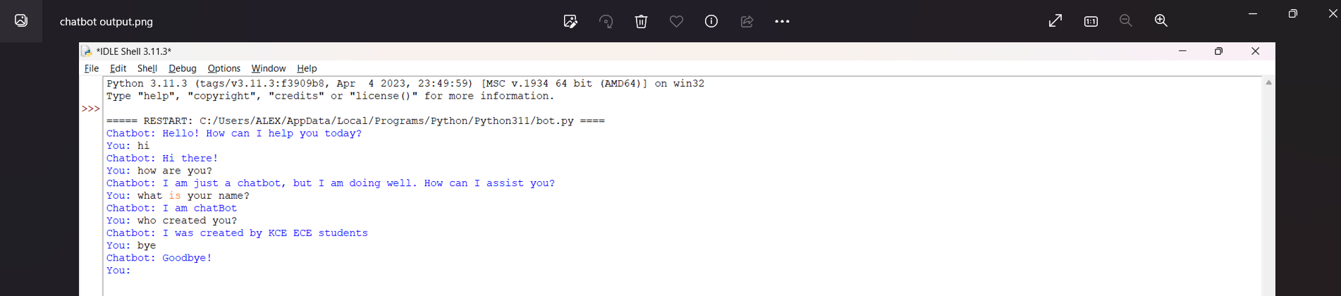

This is a sample output of our chatbot project.